Nama : Sidna Muhammad Zen

NIM : 18090144

Kelas : 5B

**PRAKTIKUM 4**

1. Source Code

Web.php > application/controller

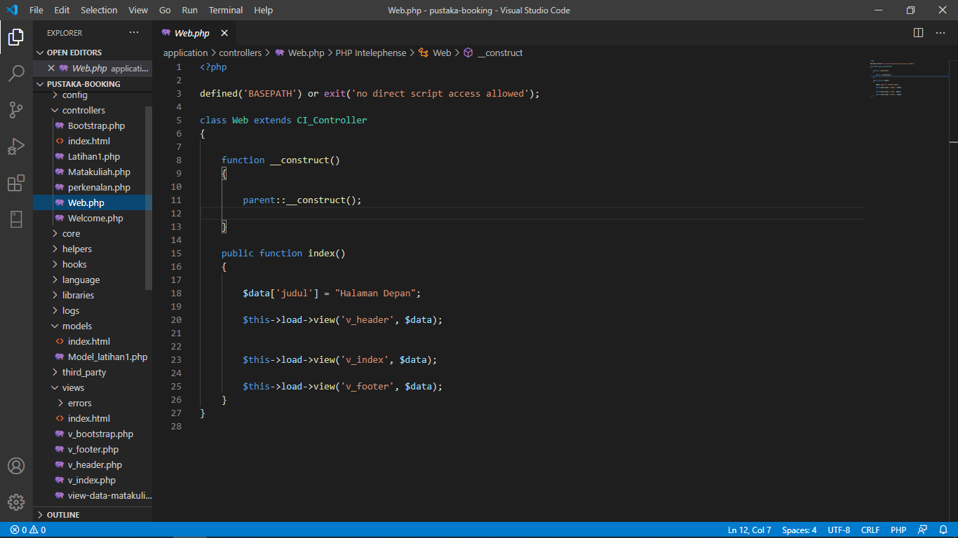

v_header.php => application/view

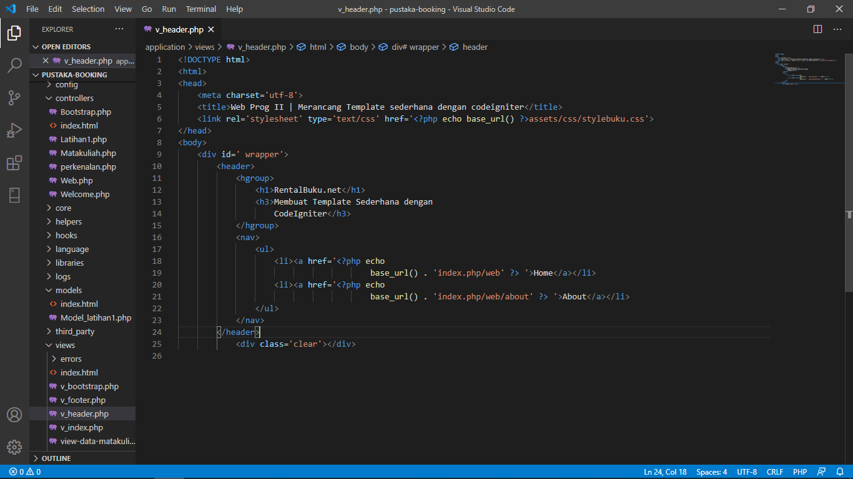

v_index.php => application/view

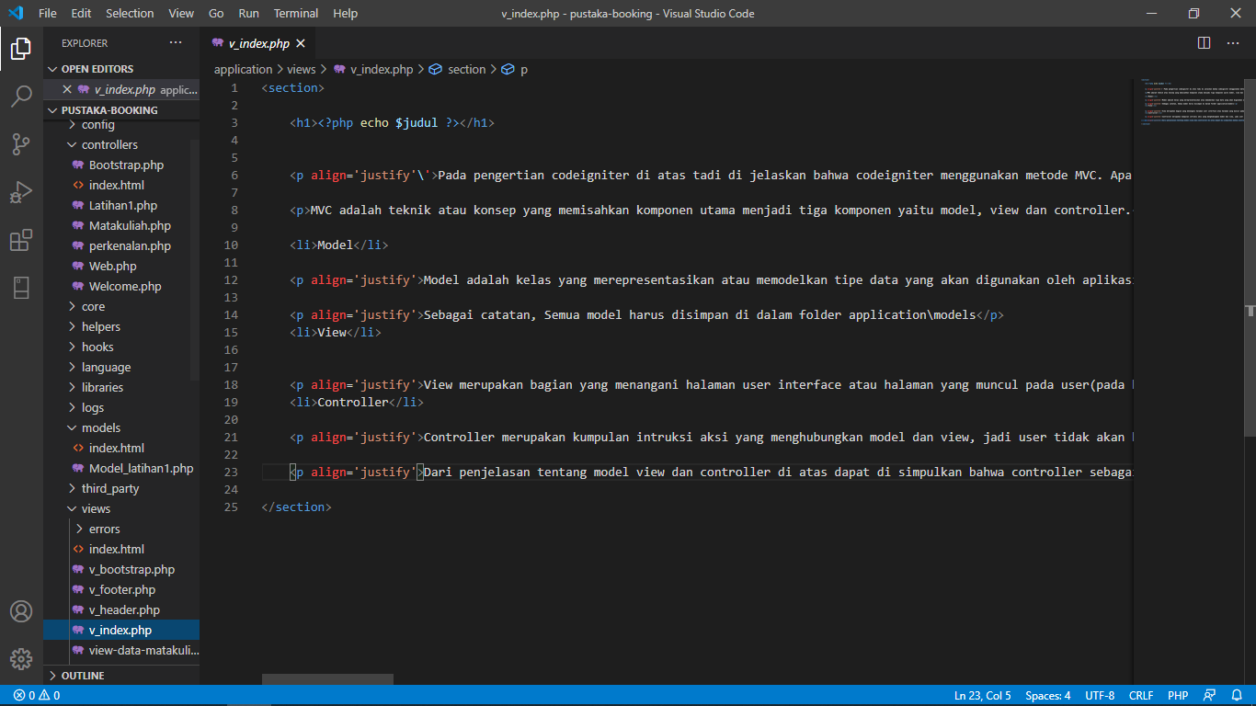

v_footer.php = > application/view

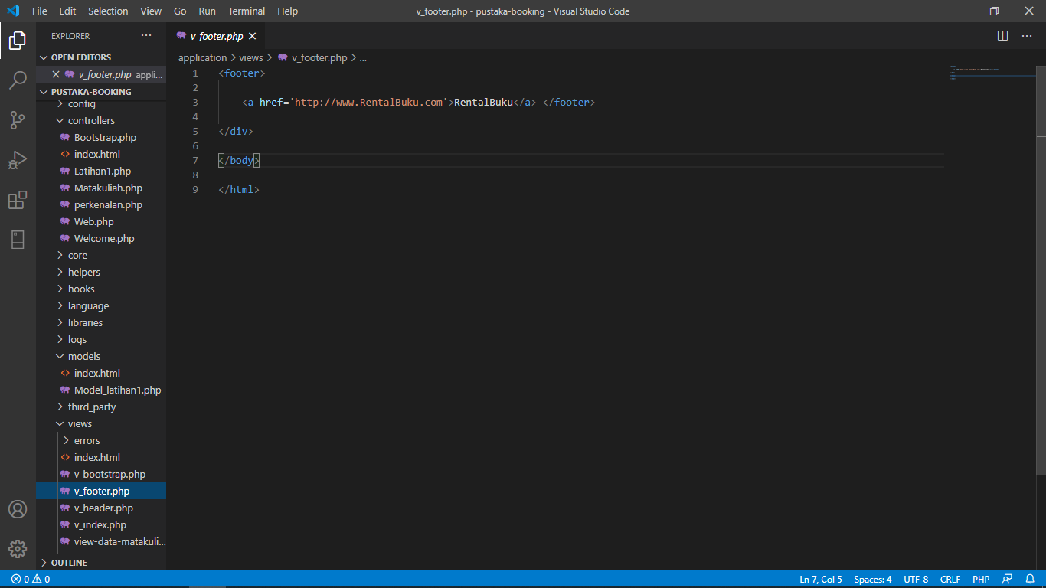

stylebuku.css => assets/css

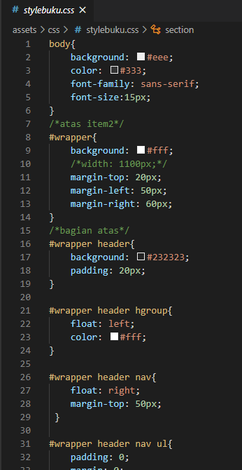

config.php => application / config

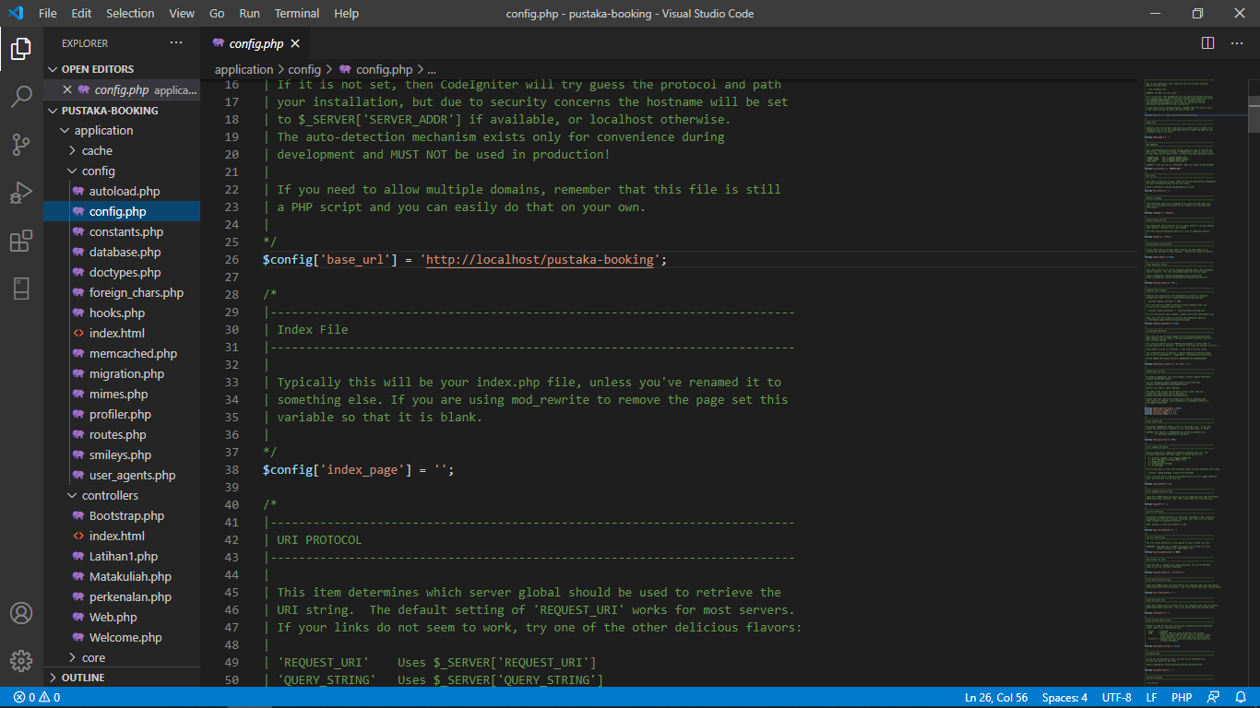

autoload.php => application / config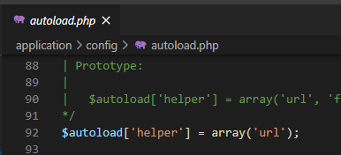

1. URL
2. <http://localhost/pustaka-booking/web>
3. Capture Hasil
4. Home

